Listing-Order Paragraphs
Prewriting Activity: Clustering
Listing-Order Paragraphs
The Three Parts of a Paragraph
Outlining
You will write paragraphs that use the listing-order pattern of organization. You will also study and practice: the three parts of a paragraph, listing-order transition signals, outlining (how to write a plan), and how to deal with compound sentences.

Clustering
Clustering - a prewriting technique that helps you get ideas to write about.
Begin by writing your chosen job or profession in the center of a piece of paper. Draw a circle around it. Then think about characteristics and abilities necessary for that job, and write down every idea that comes into your mind. Don't stop to worry if the idea is a good one or not. Write words or phrases in circles around the main circle and then connect them to the main circle .
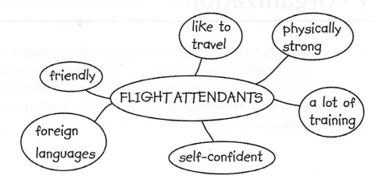
Next, think about the word or phrase in each circle. Try to think of something that illustrates the word or phrase, such as a situation when the person would need a certain characteristic or ability. Also, cross out circles that you don't want.
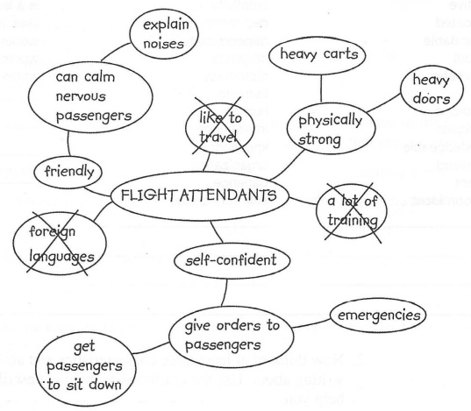
From these clusters, or groups of circles, you can begin to see which ideas to use and which ones to throw away. Use the clusters that have the most circles. Throw away the ones that have few circles because they didn't produce many ideas. Keep your clustering paper. You will use it later to write a paragraph.

Listing-Order Paragraphs
Listing order is a way of structuring a text by enumerating its items, not necessarily according to their importance, often achieved by numbering the items or by introducing them with adverbs like “first”, “then”, “finally”. In a listing-order paragraph, you divide the topic into separate points. Then you discuss one point, and then another point, and then a third point, and so on.
There are three keys to writing a listing-order paragraph:
1. Begin with a sentence that names your topic and says it has several points.
2. Write about each point separately.
3. End with a sentence that reminds your reader about the points you just discussed.
For example,
Flight Attendants
Flight attendants have three important characteristics. First of all, flight attendants are friendly. They enjoy greeting passengers and making them feel comfortable. Sometimes passengers are afraid of flying. A friendly flight attendant can talk to them and help them feel calm. For example, he or she can explain strange noises made by the aircraft. Second, flight attendants are self-confident. They give instructions to passengers, and they must be firm enough so that passengers obey them. This characteristic is especially important in emergencies. Third, flight attendants are physically strong. They push heavy carts of food and drinks up and down the aisles. They also have to open and close the heavy doors of airplanes. In short, flight attendants are friendly, self-confident, and strong.

The Three Parts of a Paragraph
In Lecture 1 you learned that a paragraph has three parts: a topic sentence, supporting sentences, and a concluding sentence. Now we will study each part of a paragraph in more detail.
The Two Parts of a Topic Sentence
A topic sentence has two parts: a topic and a controlling idea. The topic part names the topic. The controlling idea part tells what the paragraph will say about the topic. It tells the reader: This paragraph will discuss these things—and only these things—about this topic.
For example, the topic of the model paragraph above is flight attendants. What will the paragraph say about flight attendants? The controlling idea tells us: They have three characteristics. The paragraph will not tell us about their uniforms, their training, or their duties. It will only discuss three characteristics that flight attendants have.
Here are examples of other topic sentences. The topic in all three examples is the same: English. The controlling idea in each says something different about English.
English is constantly adding new words.
English borrows words from other languages.
English is necessary for many different jobs.
Usually, the topic comes first and the controlling idea comes second in the topic sentence. However, the controlling idea may come first. In the A sentences, the topic is first. In the B sentences, the controlling idea is first.
A. English borrows words from other languages.
B. Other languages give words to English.
Supporting Sentences
The middle sentences of a paragraph are the supporting sentences. Supporting sentences explain or prove the idea in the topic sentence. The supporting sentences are the biggest part of a paragraph
Listing-Order Transition Signals
A transition signal is a word or phrase that shows how one idea is related to another idea. In a listing-order paragraph, use transition signals such as First, Second, and Third to tell your reader that these are main points. Here are some transition signals that show listing order.
1. First,  First of all,  Second,  Third,  In addition,  Also,  Finally, | 2. also  , also.

1. Place most listing-order transition signals at the beginning of the sentence, and put a comma after them.
e.g.
First, living in a foreign country helps you learn another language faster than studying it at school.
In addition, small colleges are friendlier, so new students make friends more quickly.
2. Also may come in the middle of a sentence (between the subject and the verb) without a comma or at the end of a sentence with a comma.
e.g.
They also like to “hang out” at the beach with their friends.
They like to “hang out” at the beach with their friends, also.
Paragraph Unity
A paragraph must follow the rule of unity. All the sentences in a paragraph are about one main idea. Another way of expressing the rule of unity is to say that all the supporting sentences in a paragraph must be relevant. Relevant means “directly related to the main idea.”
The Concluding Sentence
Paragraphs that stand alone (that is, paragraphs that are not part of a longer composition) often have a concluding sentence at the end. A concluding sentence closes the paragraph so that the reader is not left expecting more.
Sometimes a concluding sentence reminds the reader of the main point by restating the topic sentence in different words. e.g. Indeed, a beach is a place to have fun all year. Sometimes a concluding sentence summarizes the main points.
e.g. In short, flight attendants are friendly, self-confident, and strong. To summarize, employers look for dependable, responsible team players.
NB! Do NOT introduce a new idea in your concluding sentence. Just review or repeat the ideas you have already discussed. Don’t add anything new.
Use a transition signal to tell your reader that this is the end of your paragraph. The following chart lists several conclusion signals. Notice that there is always a comma after conclusion signals.

Conclusion Signals
To conclude,  In conclusion, | To sum up,  To summarize,  In summary, | In short,  In brief,  Indeed,

Outlining
This is the outline for the paragraph about flight attendants.

Title | Flight Attendants
1. Topic sentence (in full) | Flight attendants have three important characteristics.
2. Supporting points/details | A. Friendliness  B. Self-confidence  C. Physical strength
3. Concluding sentence (in full) | In short, flight attendants are friendly, self-confident, and strong.

